***FA DOWNLOADER***

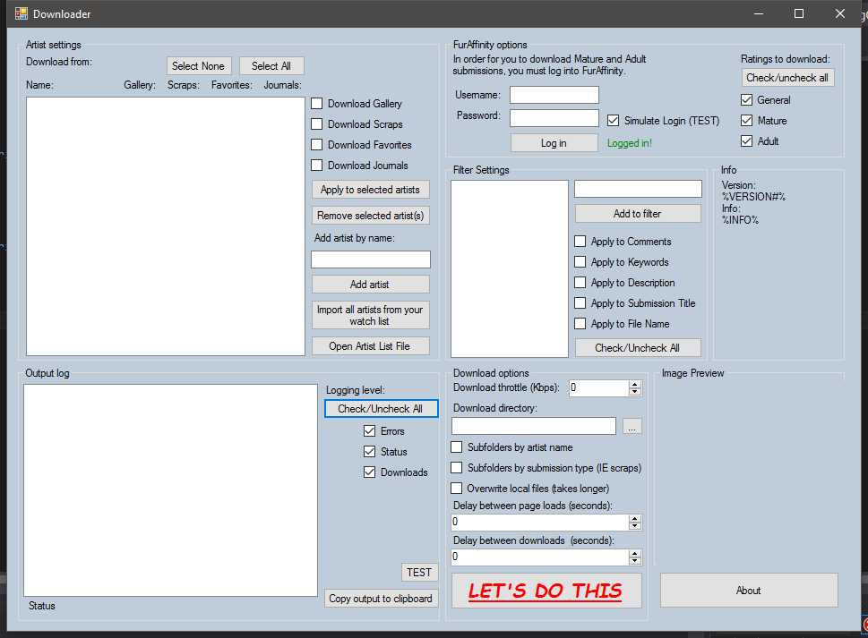

**Wish list**

**P0 P1 P2**

***SETTINGS FILES***

* **Artists.txt**
  + Lists artists to appear in UI Artist List
* **Filter.txt**
  + Lists filtered words
* **Preferences.txt**
  + Show settings available in UI
    - Username: %username%
    - Password: %password%
    - Delay Between Downloads: %downloadDelay%
    - Delay Between HTMLPages: %htmlDelay%

***UI***

* **On launch**
* If user is not logged in, grey out the following options:
  + Import all artists from your watch list
  + Mature checkbox
  + Adult checkbox
* **Check artists.txt**
* **Check filter.txt**
* **Check preferences.txt**
* **Artist settings**
  + List Box: Artist List
    - Show list of artist names grabbed from artists.txt
    - Shows which pages to download (gallery, scraps, favorites, journals)
    - Shows status of user on FA
      * Parse through each Artist page and verify their status on FA
        + Green “O” if artist is on FA
        + Yellow “!” if artist account is disabled/user is not logged in and cannot access
        + Red “X” if artist is not on FA
      * Mouse-over artists display tooltip of status
        + “Gallery available!”
        + “User account is disabled or you must log in to verify!”
        + “Gallery unavailable! Check user name.”
  + Buttons: Select/Unselect All
    - Selects/Unselects all entries in Artists list box
  + Checkboxes: Download sources
    - Determines which pages to download from
      * Gallery
      * Scraps
      * Favorites
      * Journals
  + (MISSING) Button: Check/Uncheck All
    - Check/Unchecks all pages to download from
  + Button: Apply to selected artist
    - Applies checked pages to download from to selected artists
  + Button: Remove selected artist
    - Removes selected artist from list
    - Update artists.txt
  + Textbox: Add artist by name
    - Field to manually add artist by name
  + Button: Add artist
    - Adds artist from Textbox to the list
      * Sort alphabetically
      * Update artists.txt
  + Button: Import all artists from your watch list
    - Parses user’s watch list and adds all artists <http://www.furaffinity.net/watchlist/by/%USER%/>
  + Button: Open Artist List file
    - Opens artisits.txt for manual editing
* **FurAffinity Options**
  + Text box: Username
  + Text box: Password
    - Displays asterisks
  + (MISSING) Check box: Show Password
    - Shows password when checked
  + Button: Login
    - When pressed, parse FA and log user in
      * If no entries exist in artists.txt, prompt to import artist list.
      * If login fails, prompt user
        + “Failed to log in. Please verify your credentials”
  + Lable: Login Status
    - Black “Not logged in” when user is not logged in
    - Black “Logging in…” when user clicks Login Button
    - Green “Logged in!” when log in is successful
    - Red “Failed to log in” when log in fails
  + Checkboxes: Ratings
    - Allows downloading of specific of images on submission page (or gallery page if possible)
      * General
      * Mature
      * Adult
  + Box: Check/Uncheck all
    - Check/Unchecks all ratings
  + (MISSING) Label: FA Status
    - Shows status of FA. (Online, offline, down for mainitainence)
* **Download options**
  + Numerical Up/Down: Download throttle (kbps)
    - Throttles download speeds
    - Defaults to 0
  + Download directory
    - Text field
      * Allows user to copy/paste directory
    - Folder Select button
      * Brings up folder select and populates text field
  + Checkbox: Subfolders by artist name
    - Sorts files into subfolders of the artist name
  + Checkbox: Subfolders by submission type
    - Sorts files subfolders into their type
      * Gallery
      * Scraps
      * Favorites
      * Journals
  + Numeric Up/Down: Delay between page loads (seconds)
    - Increments by 0.25
    - Delays after an HTML file is loaded
      * Defaults to 5
  + Numeric Up/Down: Delay between downloads (seconds)
    - Increments by 0.25
    - Delays after file is downloaded
      * Defaults to 5
  + Download button
    - Runs program
      * Greys out the following:
        + All FurAffinity options
        + All Filter settings
        + Artist settings

Checkbox: Download Gallery

Checkbox: Download Scraps

Checkbox: Download Favorites

Checkbox: Download Journals

Button: Apply to selected artists

Button: Import all artists from your watch list

* + - * + Download options:

Text field/button: Download directory

Checkbox: Subfolders by artist name

Checkbox: Subfolders by submission type

Checkbox: Overwrite local files

* + - Becomes “Cancel Downloads” button
* **Output log:**
  + List box: Output
    - Displays output from program
  + Checkboxes: Logging Level
    - Errors
      * Displays errors (log in error, page failed to load error, user does not exist error, etc)
    - Status
      * Status of program
    - Downloads
      * Shows download status
  + Label: Status
    - Displays status of program
  + Button: Copy output to clipboard
    - Copies the output to clipboard
  + (MISSING) Button: Clear Log
    - Clears the output log
  + (MISSING) Checkbox: Create log
    - Writes a .txt of the output log
      * FADownloaderOutput.yyyy.mm.dd.time.txt
* Filter settings:
  + List box: Filter
    - Which words to filter
  + Text field:
    - Words to add to filter
  + Button: Add to filter
    - Add word to filter
  + Checkboxes: Apply filter to
    - Comments
    - Keywords
    - Description
    - Submission Title
    - File Name
  + Button: Check/Uncheck All
    - Check/Unchecks all Apply Filter To checkboxes
  + (MIISSING) Button: Remove from filter
    - Removes selected entry in ListBox from filter
  + (MISSING) Button: Open Filter List File
    - Opens filter.txt
* **Image Preview**
  + Displays an image of the most recently downloaded file
    - Only applicable to JPG, PNG and GIF
* **Info**
  + Shows generic info
* **About button**
  + Pops up a new window with a program description

***ARTIST HANDLER***

* **HTML links generated from artist names**
  + Take array/list of user names and generate:
    - [http://furaffinity.net/gallary/%artist%](http://furaffinity.net/gallary/%25artist%25)
    - [http://furaffinity.net/scraps/%artist%/](http://furaffinity.net/scraps/%25artist%25/)
    - [http://furaffinity.net/favorites/%artist%/](http://furaffinity.net/favorites/%25artist%25/)
    - [http://furaffinity.net/journals/%artist%/](http://furaffinity.net/journals/%25artist%25/)
  + Maintained alphabetically

***LOGIN HANDLER:***

* + **If user is logged in, skip the rest**
    - Output (status):
      * “%user% is logged in. Skipping.”
  + **Parse Login page**
    - Output (status):
      * “Login paged reached.”
  + **Insert credentials**
  + **Log in**
    - Output (status):
      * “Logging in…”
  + **Verify log in by parsing Logged In results page**
    - If login fails, prompt user
      * Output (ERROR):
        + =================================
        + Login failed. Please verify your credentials.
        + =================================
      * Pop up new form
        + “Login failed. Please verify your credentials.”
        + Retry Login button

Exits new form

* + - * + “If you proceed, Mature and Adult submissions will not be downloaded.”
        + Proceed anyway button

Exits new form, runs HTML parser

***HTML PARSER:***

* Delay between going link to link (to bypass spam detection)
* Verify links loads.
  + If link fails to load:
    - Log (ERROR):
      * Page %currentPage% failed to load.
* HTML parsing

* + digThroughGallery function
    - openAllSubmissionsOnPage function
      * If submission exists,
        + %htmlDelay%
        + Load submission page
      * Else if no more submissions exist on page,
        + If Next Page Button Exists,

Go to next page

* + - * + Else

Return

* + Verify user exists http://www.furaffinity.net/user/%ARTIST%/
    - If user page loads,
      * Log (Status)
        + “User page exists. Proceeding with gallery dig”
      * %htmlDelay%
      * Load gallery
    - Else
      * Log (ERROR)
        + “User page does not exist.”

Give reason

404

FA is down.

Account has been disabled.

Unspecified. Reach out to the developer.

* + loadGallery: [http://www.furaffinity.net/gallery/%ARTIST%/](http://www.furaffinity.net/gallery/%25ARTIST%25/)
    - Run digThroughGallery function
  + loadScraps: [http://www.furaffinity.net/scraps/%ARTIST%/](http://www.furaffinity.net/scraps/%25ARTIST%25/)
    - Run digThroughGallery function
  + loadFavorites: [http://www.furaffinity.net/favorites/%ARTIST%/](http://www.furaffinity.net/favorites/%25ARTIST%25/)
    - Run digThroughGallery function
  + loadJournals: [http://www.furaffinity.net/journals/%ARTIST%/](http://www.furaffinity.net/journals/%25ARTIST%25/)
    - Open all Journals pages [http://www.furaffinity.net/journal/%JOURNAL#%/](http://www.furaffinity.net/journal/%25JOURNAL#%/)
      * If journal exists,
        + Open journal

Save HTML doc

* + - * Else
        + No journals.
* Submission page parsing [http://www.furaffinity.net/view/%SUBMISSION#%/](http://www.furaffinity.net/view/%25SUBMISSION#%/)
  + Locate Download Link
    - http://d.facdn.net/art/%ARTIST%/%SUBMISSION#%/%SUBMISSION#%.%ARTIST%_%FILENAME%.%EXTENTION%/
      * If download link fails, try http://d.facdn.net/art/%ARTIST%/%SUBMISSION#%.%ARTIST%_%FILENAME%.%EXTENTION%
  + Save Download Link to a temp doc for comparison
    - Consider %artist% for comparison of subfolder (unless unnecessary)
* %USER% watch list parsing (for importing to artists list) [http://www.furaffinity.net/watchlist/by/%USER%/](http://www.furaffinity.net/watchlist/by/%25USER%25/)
  + Locate all links and make list of all users [http://www.furaffinity.net/user/%WATCHEDUSER%](http://www.furaffinity.net/user/%25WATCHEDUSER%25)

***DOWNLOAD/FILE MANAGEMENT***

* Download files
  + Files can be downloaded
    - If file cannot be written:
      * Log (ERROR):
        + Could not write to %fileDestination%. Verify adequate disc space and verify the location is not read-only.

List reason:

404

FA is down.

Unspecified. Reach out to the developer.

* + - If file cannot be read:
  + Limiter/delay between downloads
    - Variable set by user (in case it changes)
  + Selectable download folder
    - Folder Select button
    - Editable text field
  + Skip files that exist
    - Compare names of files in list to local files
    - Option to overwrite existing
  + Artists separated into subfolders
    - Option to disable if desired
  + Submission type separated into subfolders
    - Gallery
      * Option to disable if desired
    - Scraps
      * Option to disable if desired
    - Favorites
      * Option to disable if desired
    - Journals
      * Option to disable if desired